ISO 9000 Certification
ISO (International Standards Organization) is a group or consortium of 63 countries established to plan and fosters standardization. ISO declared its 9000 series of standards in 1987. It serves as a reference for the contract between independent parties. The ISO 9000 standard determines the guidelines for maintaining a quality system. The ISO standard mainly addresses operational methods and organizational methods such as responsibilities, reporting, etc. ISO 9000 defines a set of guidelines for the production process and is not directly concerned about the product itself.

Types of ISO 9000 Quality Standards
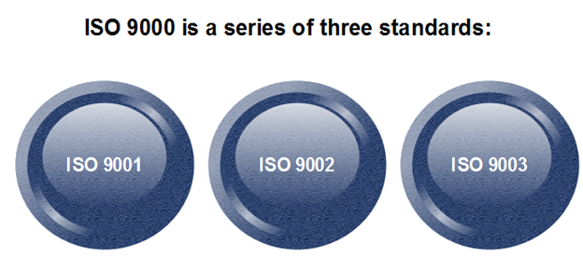
The ISO 9000 series of standards is based on the assumption that if a proper stage is followed for production, then good quality products are bound to follow automatically. The types of industries to which the various ISO standards apply are as follows.
- ISO 9001: This standard applies to the organizations engaged in design, development, production, and servicing of goods. This is the standard that applies to most software development organizations.
- ISO 9002: This standard applies to those organizations which do not design products but are only involved in the production. Examples of these category industries contain steel and car manufacturing industries that buy the product and plants designs from external sources and are engaged in only manufacturing those products. Therefore, ISO 9002 does not apply to software development organizations.
- ISO 9003: This standard applies to organizations that are involved only in the installation and testing of the products. For example, Gas companies.

How to get ISO 9000 Certification?
An organization determines to obtain ISO 9000 certification applies to ISO registrar office for registration. The process consists of the following stages:
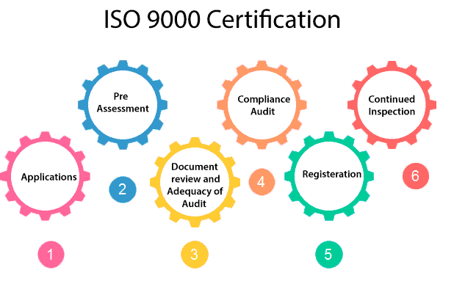
- Application: Once an organization decided to go for ISO certification, it applies to the registrar for registration.
- Pre-Assessment: During this stage, the registrar makes a rough assessment of the organization.
- Document review and Adequacy of Audit: During this stage, the registrar reviews the document submitted by the organization and suggest an improvement.
- Compliance Audit: During this stage, the registrar checks whether the organization has compiled the suggestion made by it during the review or not.
- Registration: The Registrar awards the ISO certification after the successful completion of all the phases.
- Continued Inspection: The registrar continued to monitor the organization time by time.
Why ISO Certification required by Software Industry?
There are several reasons why software industry must get an ISO certification. Some of reasons are as follows :
- This certification has become a standards for international bidding.
- It helps in designing high-quality repeatable software products.
- It emphasis need for proper documentation.
- It facilitates development of optimal processes and totally quality measurements.
Features of ISO 9001 Requirements :
- Document control –
All documents concerned with the development of a software product should be properly managed and controlled.
- Planning –
Proper plans should be prepared and monitored.
- Review –
For effectiveness and correctness all important documents across all phases should be independently checked and reviewed .
- Testing –
The product should be tested against specification.
- Organizational Aspects –
Various organizational aspects should be addressed e.g., management reporting of the quality team.
Advantages of ISO 9000 Certification :
Some of the advantages of the ISO 9000 certification process are following :
- Business ISO-9000 certification forces a corporation to specialize in “how they are doing business”. Each procedure and work instruction must be documented and thus becomes a springboard for continuous improvement.
- Employees morale is increased as they’re asked to require control of their processes and document their work processes
- Better products and services result from continuous improvement process.
- Increased employee participation, involvement, awareness and systematic employee training are reduced problems.
Shortcomings of ISO 9000 Certification :
Some of the shortcoming of the ISO 9000 certification process are following :
- ISO 9000 does not give any guideline for defining an appropriate process and does not give guarantee for high quality process.
- ISO 9000 certification process have no international accreditation agency exists.
Capability Maturity Model (CMM) was developed by the Software Engineering Institute (SEI) at Carnegie Mellon University in 1987. It is not a software process model. It is a framework that is used to analyze the approach and techniques followed by any organization to develop software products. It also provides guidelines to further enhance the maturity of the process used to develop those software products.
It is based on profound feedback and development practices adopted by the most successful organizations worldwide. This model describes a strategy for software process improvement that should be followed by moving through 5 different levels. Each level of maturity shows a process capability level. All the levels except level 1 are further described by Key Process Areas (KPA).

Principles of Capability Maturity Model (CMM)
- People’s capability is a competitive issue. Competition arises when different organizations are performing the same task (such as software development). In such a case, the people of an organization are sources of strategy and skills, which in turn results in better performance of the organization.
- The people’s capability should be defined in relation to the business objectives of the organization.
- An organization should invest in improving the capabilities and skills of the people as they are important for its success.
- The management should be responsible for enhancing the capability of the people in the organization.
- The improvement in the capability of people should be done as a process. This process should incorporate appropriate practices and procedures.
- The organization should be responsible for providing improvement opportunities so that people in the organization can take advantage of them.
- Since new technologies and organizational practices emerge rapidly, organizations should continually improve their practices and develop the abilities of people.

Shortcomings of the Capability Maturity Model (CMM)
- It encourages the achievement of a higher maturity level in some cases by displacing the true mission, which is improving the process and overall software quality.
- It only helps if it is put into place early in the software development process.
- It has no formal theoretical basis and in fact, is based on the experience of very knowledgeable people.
- It does not have good empirical support and this same empirical support could also be constructed to support other models.
- Difficulty in measuring process improvement: The SEI/CMM model may not provide an accurate measure of process improvement, as it relies on self-assessment by the organization and may not capture all aspects of the development process.
- Focus on documentation rather than outcomes: The SEI/CMM model may focus too much on documentation and adherence to procedures, rather than on actual outcomes such as software quality and customer satisfaction.
- May not be suitable for all types of organizations: The SEI/CMM model may not be suitable for all kinds of organizations, particularly those with smaller development teams or those with less structured development processes.
- May not keep up with rapidly evolving technologies: The SEI/CMM model may not be able to keep up with rapidly evolving technologies and development methodologies, which could limit its usefulness in certain contexts.
- Lack of agility: The SEI/CMM model may not be agile enough to respond quickly to changing business needs or customer requirements, which could limit its usefulness in dynamic and rapidly changing environments.

Key Process Areas (KPA)
Each of these KPA (Key Process Areas) defines the basic requirements that should be met by a software process in order to satisfy the KPA and achieve that level of maturity.
Conceptually, key process areas form the basis for management control of the software project and establish a context in which technical methods are applied, work products like models, documents, data, reports, etc. are produced, milestones are established, quality is ensured and change is properly managed.

Levels of Capability Maturity Model (CMM)
There are basically 5 levels of Capability Maturity Models. We will discuss each one of them in detail.
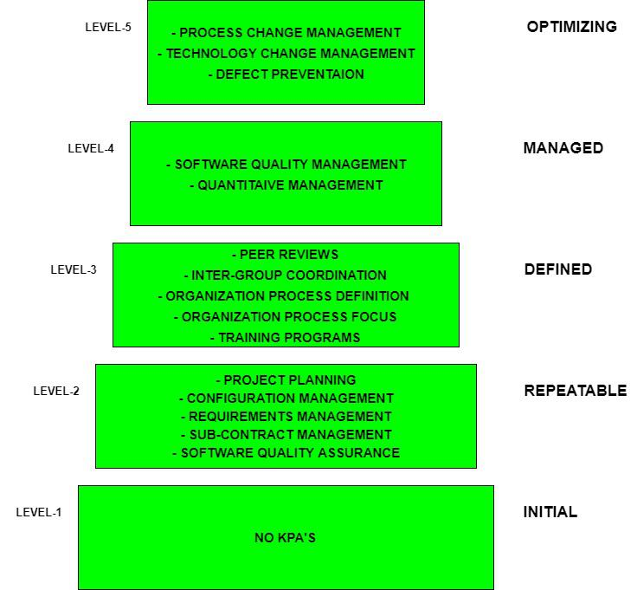
CMM

Level-1: Initial
- No KPIs defined.
- Processes followed are Adhoc and immature and are not well defined.
- Unstable environment for software development.
- No basis for predicting product quality, time for completion, etc.
- Limited project management capabilities, such as no systematic tracking of schedules, budgets, or progress.
- We have limited communication and coordination among team members and stakeholders.
- No formal training or orientation for new team members.
- Little or no use of software development tools or automation.
- Highly dependent on individual skills and knowledge rather than standardized processes.
- High risk of project failure or delays due to a lack of process control and stability.

Level-2: Repeatable
- Focuses on establishing basic project management policies.
- Experience with earlier projects is used for managing new similar-natured projects.
- Project Planning- It includes defining resources required, goals, constraints, etc. for the project. It presents a detailed plan to be followed systematically for the successful completion of good-quality software.
- Configuration Management- The focus is on maintaining the performance of the software product, including all its components, for the entire lifecycle.
- Requirements Management- It includes the management of customer reviews and feedback which result in some changes in the requirement set. It also consists of accommodation of those modified requirements.
- Subcontract Management- It focuses on the effective management of qualified software contractors i.e. it manages the parts of the software developed by third parties.
- Software Quality Assurance- It guarantees a good quality software product by following certain rules and quality standard guidelines while developing.

Level-3: Defined
- At this level, documentation of the standard guidelines and procedures takes place.
- It is a well-defined integrated set of project-specific software engineering and management processes.
- Peer Reviews: In this method, defects are removed by using a number of review methods like walkthroughs, inspections, buddy checks, etc.
- Intergroup Coordination: It consists of planned interactions between different development teams to ensure efficient and proper fulfillment of customer needs.
- Organization Process Definition: Its key focus is on the development and maintenance of standard development processes.
- Organization Process Focus: It includes activities and practices that should be followed to improve the process capabilities of an organization.
- Training Programs: It focuses on the enhancement of knowledge and skills of the team members including the developers and ensuring an increase in work efficiency.

Level-4: Managed
- At this stage, quantitative quality goals are set for the organization for software products as well as software processes.
- The measurements made help the organization to predict the product and process quality within some limits defined quantitatively.
- Software Quality Management: It includes the establishment of plans and strategies to develop quantitative analysis and understanding of the product’s quality.
- Quantitative Management: It focuses on controlling the project performance in a quantitative manner.

Level-5: Optimizing
- This is the highest level of process maturity in CMM and focuses on continuous process improvement in the organization using quantitative feedback.
- The use of new tools, techniques, and evaluation of software processes is done to prevent the recurrence of known defects.
- Process Change Management: Its focus is on the continuous improvement of the organization’s software processes to improve productivity, quality, and cycle time for the software product.
- Technology Change Management: It consists of the identification and use of new technologies to improve product quality and decrease product development time.
- Defect Prevention It focuses on the identification of causes of defects and prevents them from recurring in future projects by improving project-defined processes.

CMM (Capability Maturity Model) vs CMMI (Capability Maturity Model Integration)
Aspects | Capability Maturity Model (CMM) | Capability Maturity Model Integration (CMMI)
Scope | Primarily focused on software engineering processes. | Expands to various disciplines like systems engineering, hardware development, etc.
Maturity Levels | Had a five-level maturity model (Level 1 to Level 5). | Initially had a staged representation; introduced continuous representation later.
Flexibility | More rigid structure with predefined practices. | Offers flexibility to tailor process areas to organizational needs.
Adoption and Popularity | Gained popularity in software development industry. | Gained wider adoption across industries due to broader applicability.

Levels of CMMI
There are basically 5 performance levels of the CMMI Model.
Level 1: Initial: Processes are often ad hoc and unpredictable. There is little or no formal process in place.
Level 2: Managed: Basic project management processes are established. Projects are planned, monitored, and controlled.
Level 3: Defined: Organizational processes are well-defined and documented. Standardized processes are used across the organization.
Level 4: Quantitatively Managed: Processes are measured and controlled using statistical and quantitative techniques. Process performance is quantitatively understood and managed.
Level 5: Optimizing: Continuous process improvement is a key focus. Processes are continuously improved based on quantitative feedback.

Software Engineering Institute Capability Maturity Model (SEICMM)
The Capability Maturity Model (CMM) is a procedure used to develop and refine an organization's software development process.
The model defines a five-level evolutionary stage of increasingly organized and consistently more mature processes.
CMM was developed and is promoted by the Software Engineering Institute (SEI), a research and development center promote by the U.S. Department of Defense (DOD).
Capability Maturity Model is used as a benchmark to measure the maturity of an organization's software process.

Methods of SEICMM
There are two methods of SEICMM:
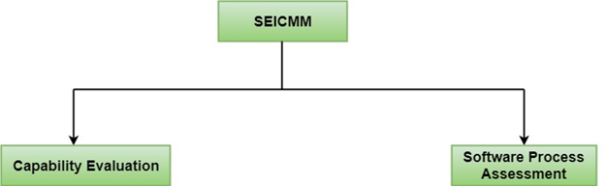
Capability Evaluation: Capability evaluation provides a way to assess the software process capability of an organization. The results of capability evaluation indicate the likely contractor performance if the contractor is awarded a work. Therefore, the results of the software process capability assessment can be used to select a contractor.
Software Process Assessment: Software process assessment is used by an organization to improve its process capability. Thus, this type of evaluation is for purely internal use.
SEI CMM categorized software development industries into the following five maturity levels. The various levels of SEI CMM have been designed so that it is easy for an organization to build its quality system starting from scratch slowly.
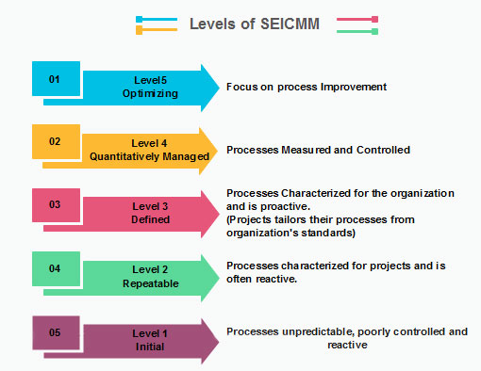

Level 1: Initial
Ad hoc activities characterize a software development organization at this level. Very few or no processes are described and followed. Since software production processes are not limited, different engineers follow their process and as a result, development efforts become chaotic. Therefore, it is also called a chaotic level.

Level 2: Repeatable
At this level, the fundamental project management practices like tracking cost and schedule are established. Size and cost estimation methods, like function point analysis, COCOMO, etc. are used.

Level 3: Defined
At this level, the methods for both management and development activities are defined and documented. There is a common organization-wide understanding of operations, roles, and responsibilities. The ways through defined, the process and product qualities are not measured. ISO 9000 goals at achieving this level.

Level 4: Managed
At this level, the focus is on software metrics. Two kinds of metrics are composed.
Product metrics measure the features of the product being developed, such as its size, reliability, time complexity, understandability, etc.
Process metrics follow the effectiveness of the process being used, such as average defect correction time, productivity, the average number of defects found per hour inspection, the average number of failures detected during testing per LOC, etc. The software process and product quality are measured, and quantitative quality requirements for the product are met. Various tools like Pareto charts, fishbone diagrams, etc. are used to measure the product and process quality. The process metrics are used to analyze if a project performed satisfactorily. Thus, the outcome of process measurements is used to calculate project performance rather than improve the process.

Level 5: Optimizing
At this phase, process and product metrics are collected. Process and product measurement data are evaluated for continuous process improvement.

Key Process Areas (KPA) of a software organization
Except for SEI CMM level 1, each maturity level is featured by several Key Process Areas (KPAs) that contains the areas an organization should focus on improving its software process to the next level. The focus of each level and the corresponding key process areas are shown in the fig.
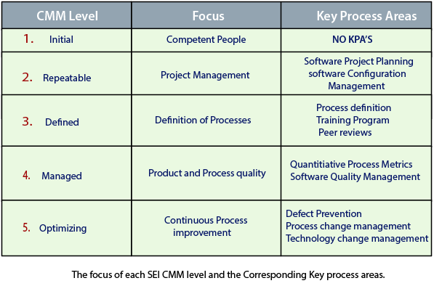
SEI CMM provides a series of key areas on which to focus to take an organization from one level of maturity to the next. Thus, it provides a method for gradual quality improvement over various stages. Each step has been carefully designed such that one step enhances the capability already built up.

People Capability Maturity Model (PCMM)
PCMM is a maturity structure that focuses on continuously improving the management and development of the human assets of an organization.
It defines an evolutionary improvement path from Adhoc, inconsistently performed practices, to a mature, disciplined, and continuously improving the development of the knowledge, skills, and motivation of the workforce that enhances strategic business performance.
The People Capability Maturity Model (PCMM) is a framework that helps the organization successfully address their critical people issues. Based on the best current study in fields such as human resources, knowledge management, and organizational development, the PCMM guides organizations in improving their steps for managing and developing their workforces.
The People CMM defines an evolutionary improvement path from Adhoc, inconsistently performed workforce practices, to a mature infrastructure of practices for continuously elevating workforce capability.
The PCMM subsists of five maturity levels that lay successive foundations for continuously improving talent, developing effective methods, and successfully directing the people assets of the organization. Each maturity level is a well-defined evolutionary plateau that institutionalizes a level of capability for developing the talent within the organization
The five steps of the People CMM framework are:
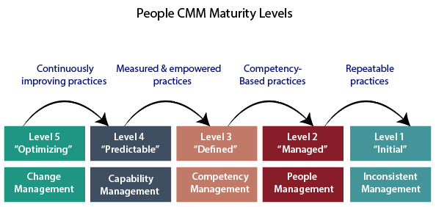

Initial Level: Maturity Level 1
The Initial Level of maturity includes no process areas. Although workforce practices implement in Maturity Level, 1 organization tend to be inconsistent or ritualistic, virtually all of these organizations perform processes that are defined in the Maturity Level 2 process areas.

Managed Level: Maturity Level 2
To achieve the Managed Level, Maturity Level 2, managers starts to perform necessary people management practices such as staffing, operating performance, and adjusting compensation as a repeatable management discipline. The organization establishes a culture focused at the unit level for ensuring that person can meet their work commitments. In achieving Maturity Level 2, the organization develops the capability to handle skills and performance at the unit level. The process areas at Maturity Level 2 are Staffing, Communication and Coordination, Work Environment, Performance Management, Training and Development, and Compensation.

Defined Level: Maturity Level 3
The fundamental objective of the defined level is to help an organization gain a competitive benefit from developing the different competencies that must be combined in its workforce to accomplish its business activities. These workforce competencies represent critical pillars supporting the strategic workforce competencies to current and future business objectives; the improved workforce practices for implemented at Maturity Level 3 become crucial enablers of business strategy.

Predictable Level: Maturity Level 4
At the Predictable Level, the organization handles and exploits the capability developed by its framework of workforce competencies. The organization is now able to handle its capacity and performance quantitatively. The organization can predict its capability for performing work because it can quantify the ability of its workforce and of the competency-based methods they use performing in their assignments.

Optimizing Level: Maturity Level 5
At the Optimizing Level, the integrated organization is focused on continual improvement. These improvements are made to the efficiency of individuals and workgroups, to the act of competency-based processes, and workforce practices and activities.

